SOURCE CODE :

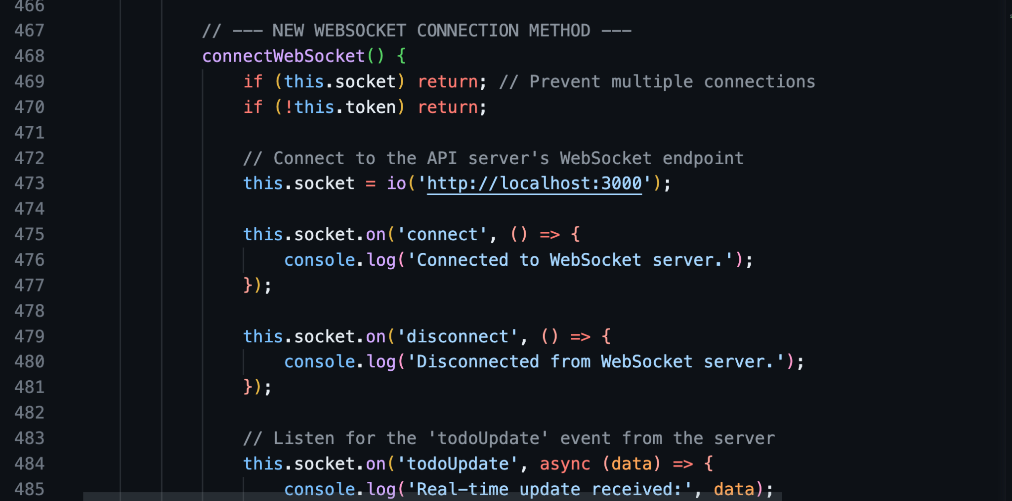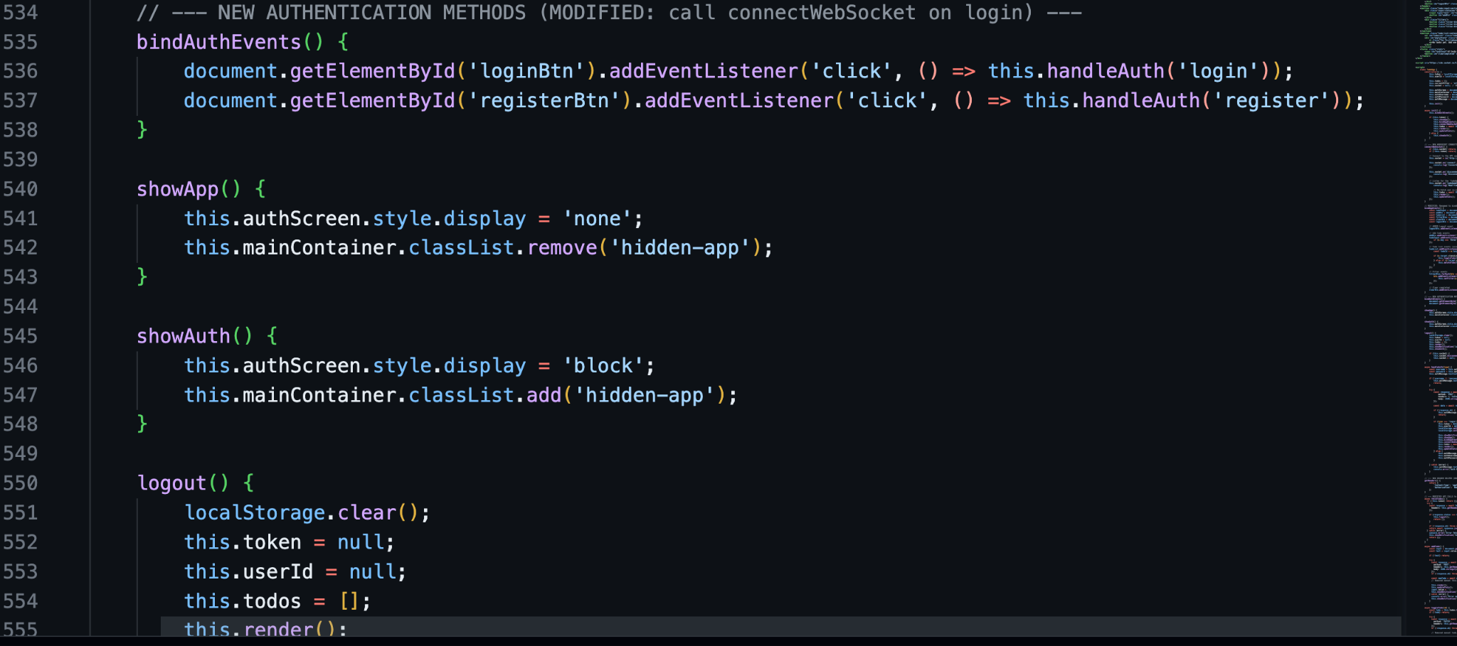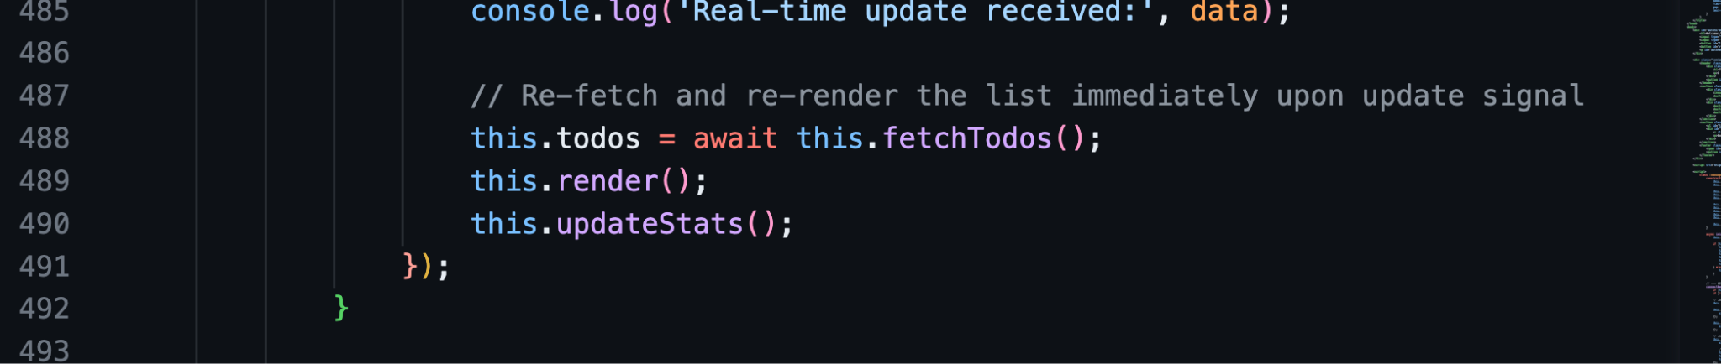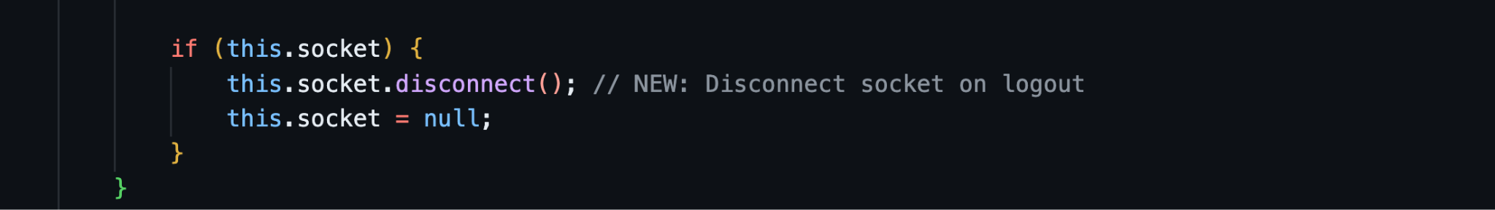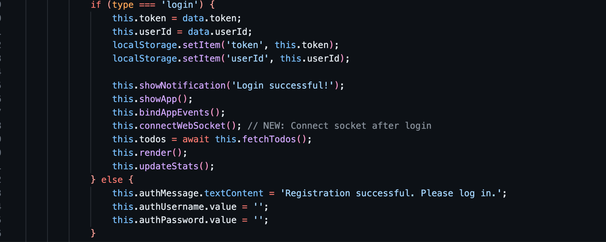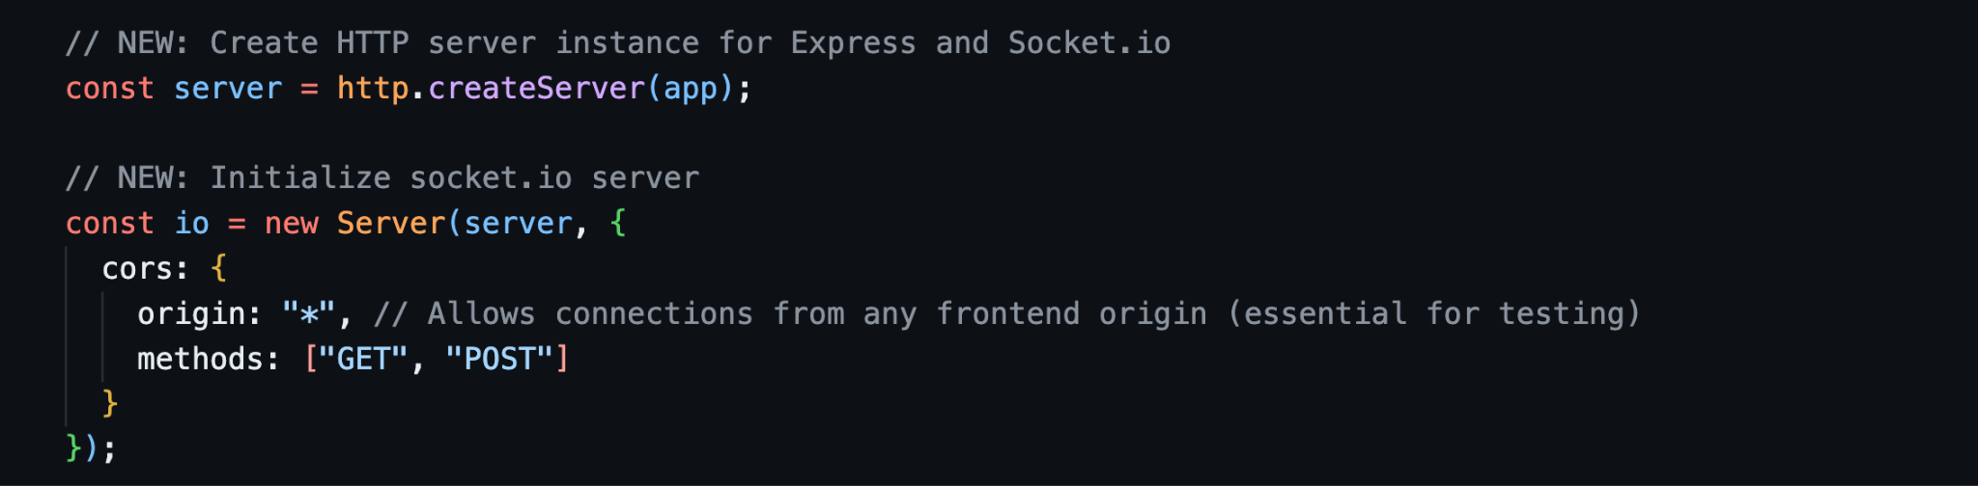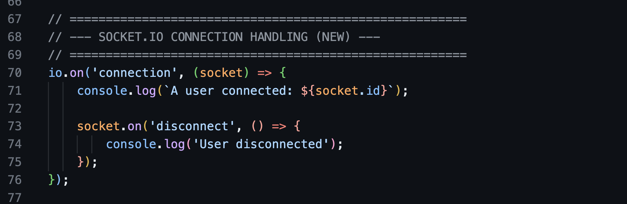

OUTPUT :

FIG: OPENED APP IN SAFARI AND MADE CHANGES

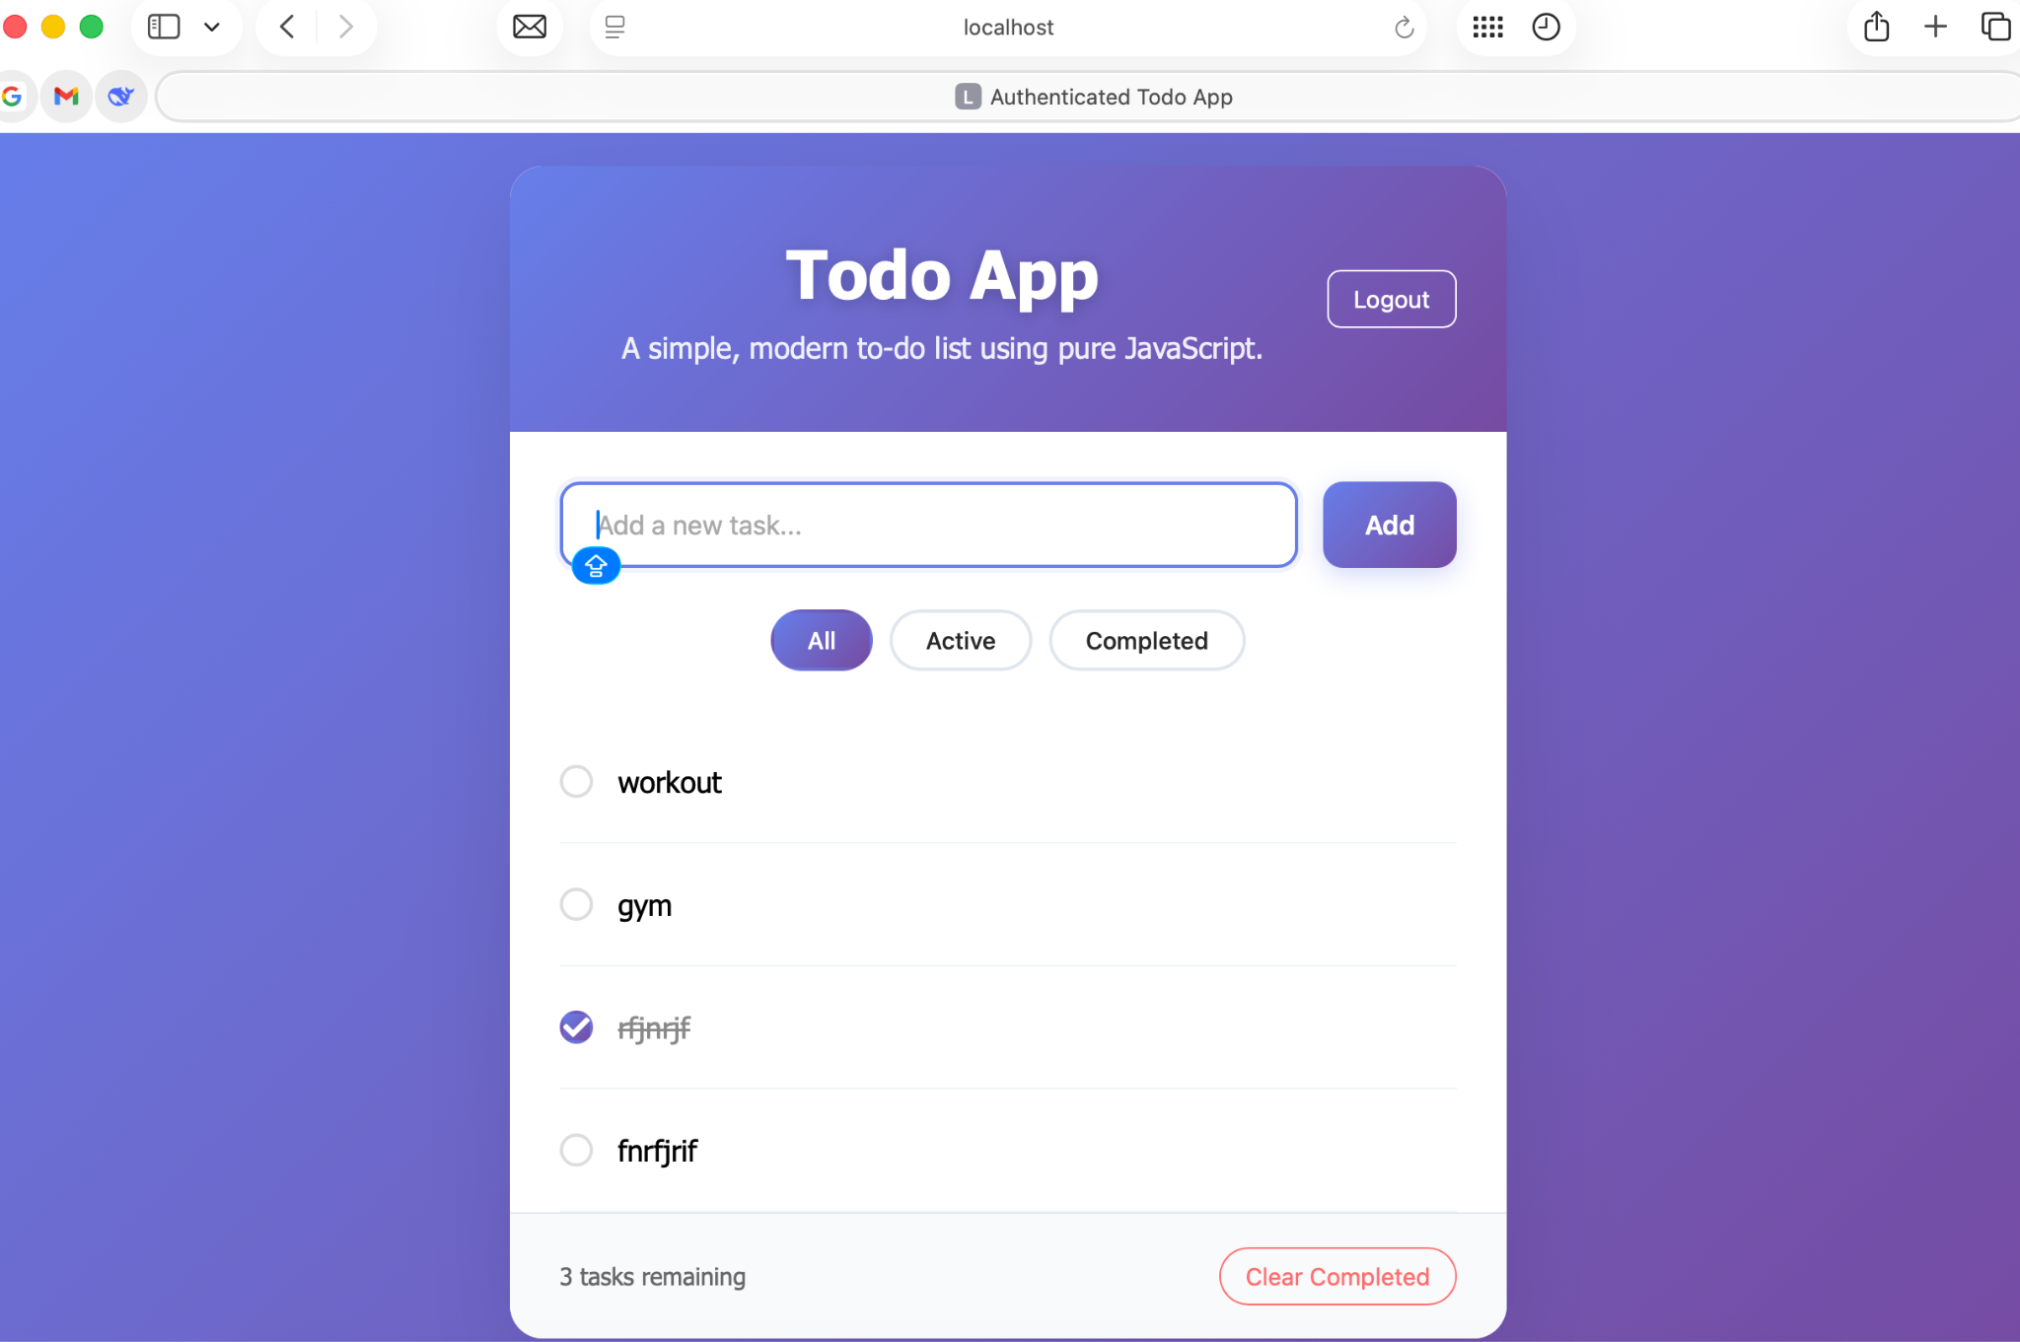

FIG 2: CHANGES APPEARED IN THE CHROME EXTENSION

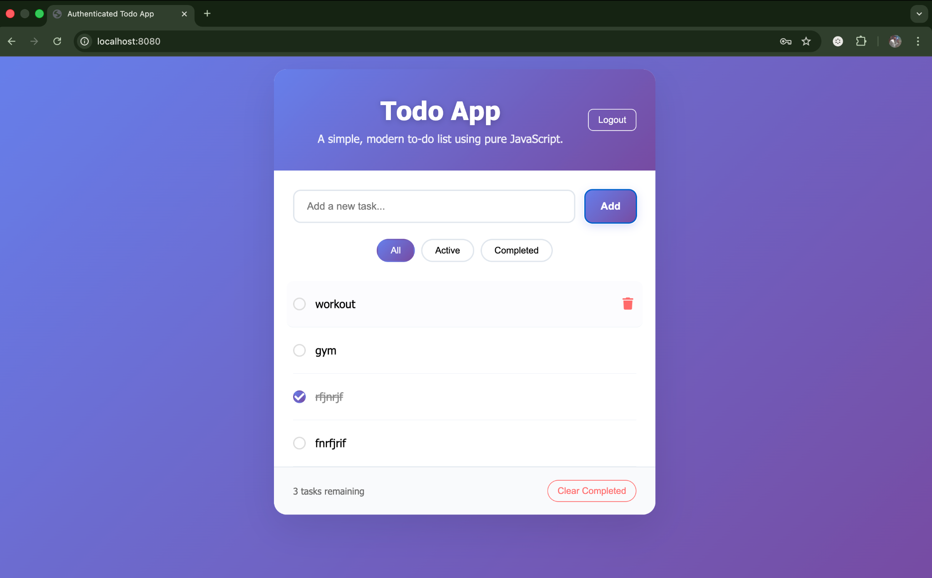

Fig : 3 task added in safari

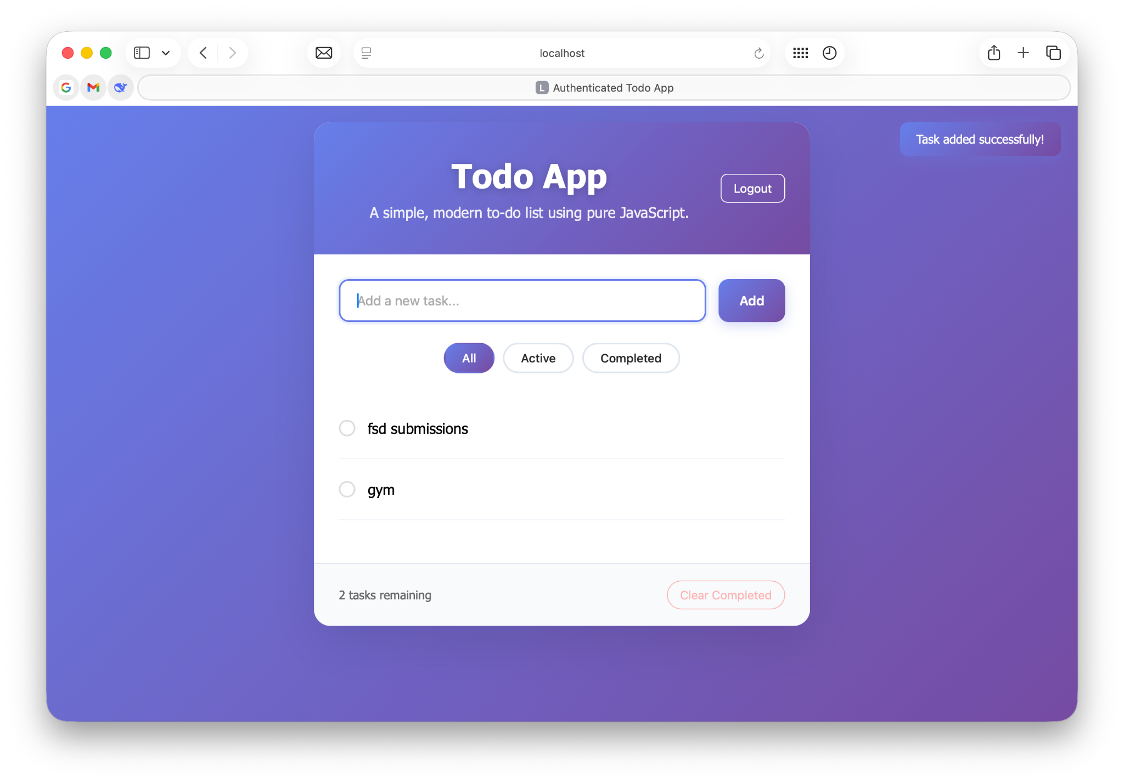

Fig: 4 : task updated in chrome

